Wireless ad hoc network
Project subbited
BY
Deepak pant
Under the guidance of

Praven joshi
Ever green sr. sec. school
CERTIFICATE
This is specifies due to the project certificate wireless ad hoc network being situated is Evergreen senior secondary
school haldwani for project work for information technology is required to work named by Deepak pant under my guidance
Summited
Mr praveen joshi
Ever green sry secular school
Research on wireless ad hoc network has been ongoing for decades the history of wireless and hoc network can be tracked back to the defense Advanced Research products agency DAPRA packet radio network SURAD program ad hoc network play an important role in military application and related research efforts for example the global mobile information system program in recent years have seen a new spate of industrial and commercial application for wireless ad hoc network viable communication equipment and portable communication become more compact and available
Since there emergencies in 1970 wireless network have become increaseingly popular in the communication industry these network provide mobile users with ubiquitous computing capability and information access regardless of users location they are currently two variation of mobile wireless network works infrastructure and infrastructure less networks
The infrastructure network have fixed and wired gateway or fixed base stations which are connected to other base stations .A Hand-OFFof occurs as mobile host off another mobile travels out of the range of one based solution and into the range of another and Thus Host able to continue communication seamlessly thought the network example application of the type include wireless local area network mobile phone.
The other type of wireless network infrastructure less network is known as mobile ad hoc network these networks have no fixed routers every note could be Reuters all nodes are capable of movement and can be connected dynamically in arbitrarily manner the responsibility for organising and controlling the network disturbed among the terminal themselves the entire network in mobile and individual terminals are allowed to move freely.
Characters and fundamental challenges of wireless ad hoc network
Since wireless ad hoc network are inherently different from the well known wired network it is absolutely new architecture does some challenges raise from the two keys excerpts self organization and wireless transport and information .
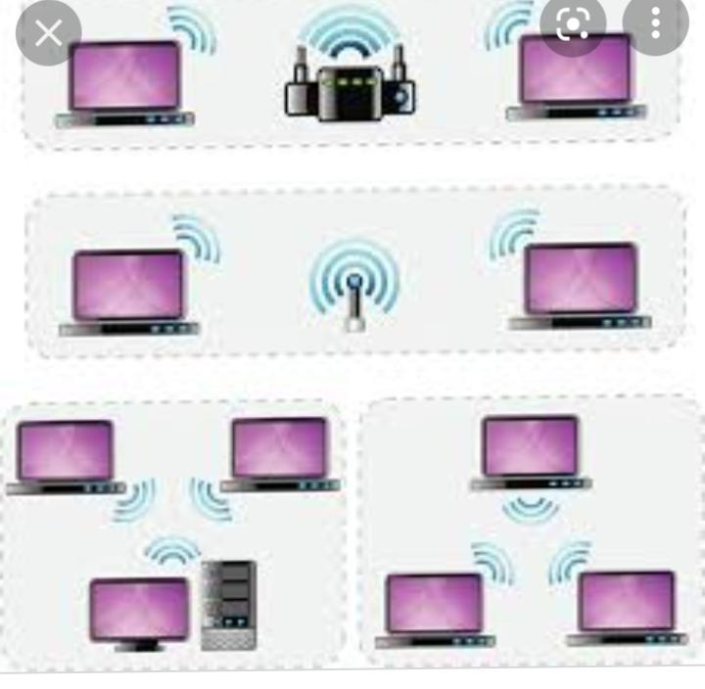
First of all,scncethe nodes in the wireless ad hoc network are free to move orbit Lee at anytime so the network works to poorly of minute may change randomly and rapidly at and predictable time this make routing difficulties because the topology is constantly changing and nudes cannot be assumed to have president data storage in the roast case we do not even know whether the node will still remain next minute because the node will leave the network at any minute.
When should you use an ad hoc wireless network,?
Ad hoc network are used frequently in new types of wireless engineering they required minimal conflagration and can be deployed quickly which makes them suitable for emergencies such as natural disaster or military conflict thanks for the presence of dynamic and adaptive routing protocols these network can be configured quickly these improve to on demand network are useful for Putting together a small in expensive old wireless LAN without the need for wireless infrastructure equipment they also work well as temporary fall back mechanism if equipment for in infrastructure mode network fail
Manet. A mobile ad hoc network involves mobile device communicating directly with one another a MANET is a network of wireless mobile device without an infrastructure that are self organising and self conferencing a MANET is something referred to as an,‘ on the fly’ or spontaneous network
SPAN, Smartphone ad hoc network employee exiting hardware such as WiFi and Bluetooth and software protocols built into a smartphone operating system to create P2 P network without relying on cellular career network wireless access point or other traditional network infrastructure in equipment different from traditional hub and spoke network such as WiFi direct SPAN support multi hop release multi hop really is a process of sending traffic from device A to device see using intermediately device be there for device A and see do not need to have a direct PTP connection established for traffic to reach its destination and because SPAN are fully dynamic in nature there is no notion offer group leader in a type of application and pause peers can join or leave without harming the network.
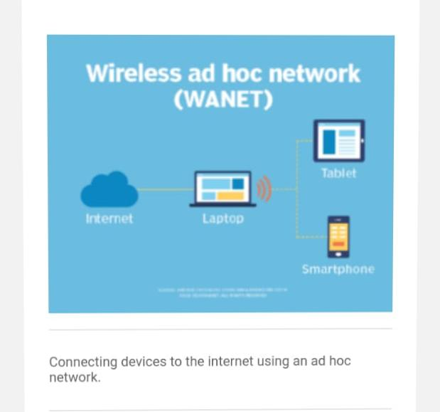
Vehicular ad hoc network, These network type in words device in vehicles that are used for communicating between them are roadside equipment an example the in vehicle safety and security system on star

